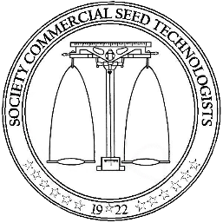
Society of Commercial Seed Technologists

Application for Professional Membership
Applicant Name Phone
Employer/Company Fax
Email
Address

Date of RST/CVT/CPT certification
Date of Inactive status if applicable
Are you a current member in good standing with SCST?
If no, explain.

Please return to: Society of Commercial Seed Technologists
653 Constitution Ave NE
Washington, DC 20002
Phone: (202) 870-2412
Email: scst@seedtechnology.net

